BANKING DATA ANALYSIS

BY: SUDHIR JANGRA

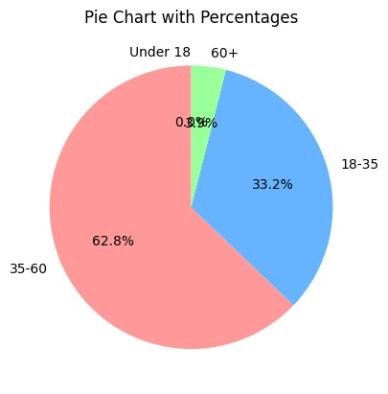

TOTAL PERCENTAGES AGE GROUPS

Bank reached out to 35-60 aged customers

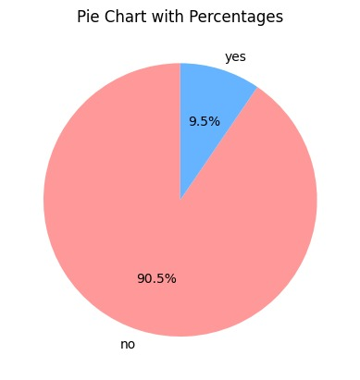 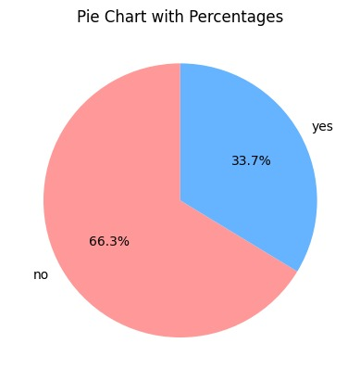

RESPONSE RATES OF 35-60 AGE GROUP RESPONSE RATES OF 60+ AGE GROUP

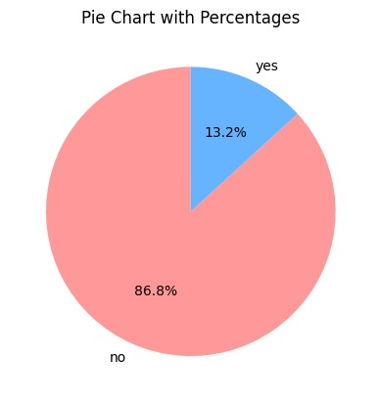

RESPONSE RATES OF 18-35 AGE GROUP

"The analysis revealed that customers aged 60+ yield the highest positive response rates. This demographic typically accumulates significant savings over their lifetime, making them a valuable target audience. Therefore, it is recommended that the bank prioritize outreach efforts to this age group to maximize engagement and potential returns."

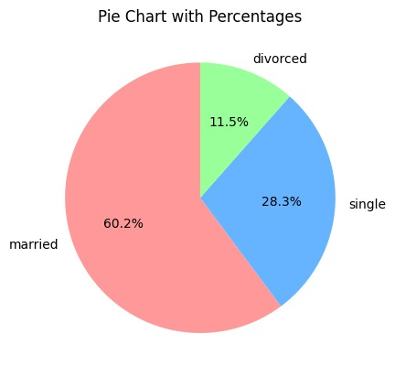

TOTAL PERCENTAGES FOR DIFFERENT MARRITAL STATUS CUSTOMERS

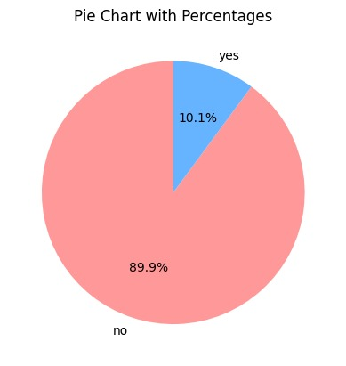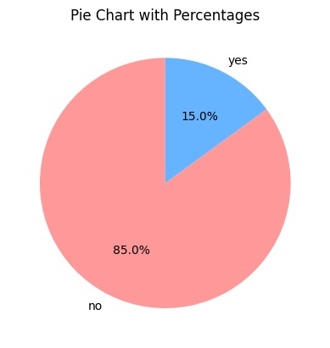

RESPONSED FORM MARRIED CUSTOMERS RESPONSED FORM SINGLE CUSTOMERS

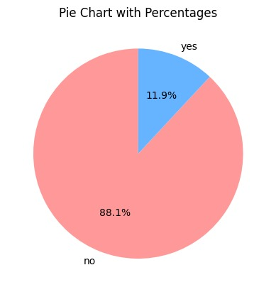

RESPONSES FROM DIVORCED CUSTOMERS

Single customers of the bank tend to have fewer daily financial obligations, resulting in a higher likelihood of positive responses. This demographic's relatively lower financial commitments make them more receptive to the bank's offering."

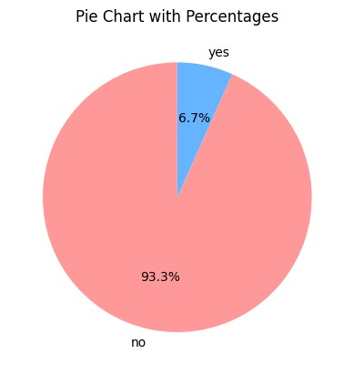

RESPONSES FORM THE CUSTOMERS WHO ALREADY HAVE LOAN ON THEIR ACCOUNT.

"Analysis of customer responses reveals that individuals currently servicing a loan on their account are less likely to respond positively. This suggests that the bank should exclude existing loan holders from targeting efforts, focusing instead on customers without outstanding loans."

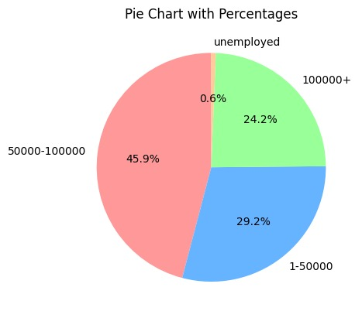

PERCENTAGES OF CUSTOMERS ON THE BASIS OF THEIR SALARY

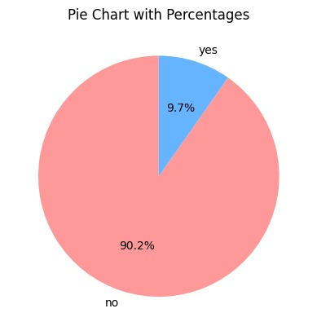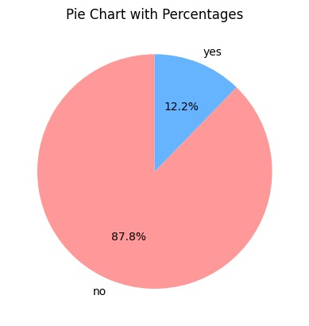

Salary = 1-50k Salary = 50k – 1 lakh

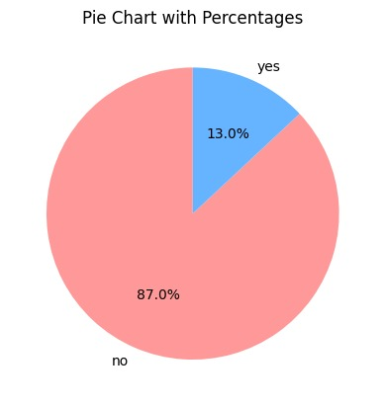

Salary = 1 lakh+

"High-salary customers show more positive responses, while low-salary customers are less responsive."